A Forest Garden Farm Plan for Finca Fila Marucha
Especias Ceilan SA
Centro de Capacitación Bosques Análogos
Londres de Aguirre, Costa Rica

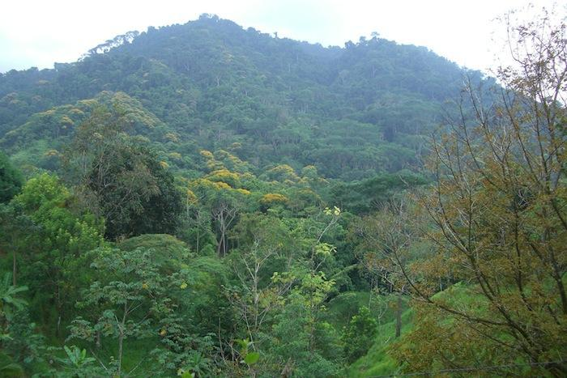

A view of Finca Fila Marucha due East
Background:
The Finca Fila Marucha project is being implemented on the grounds of Centro de Capacitación Bosques Análogos in Londres de Aguirre, Central Pacific region of Costa Rica. This project is based on having redesigned the landscape over 29 years from pasture lands to the present analog forests or forest gardens and having established a stable management system of the farm. The responsible party for implementation is the owner of the farm, Especias Ceilán SA. This document is generated to facilitate the certification of the products and management decisions that will be made on the Finca Fila Marucha (FFM) so that the requirements and outputs of the project can continue to be efficiently implemented.
A Forest Garden Farm Plan is a clear planning document that demonstrates the concepts of ‘Organic ‘production, crop diversification and biodiversity development through the application of Analog Forestry design on the land. This is also a pre-requisite for obtaining Forest Garden Product (FGP) certification. The plan is presented as a series of overlays demarcating each variable addressed. The variables are discussed under the following broad headings. However, it will be seen that all of these variables overlap with others. Thus for management needs, any variables of interest can be overlapped to facilitate decision- making.
The Forest Garden Farm Plan (FGFP) is a detailed map that records the existing physical and ecological structure of the property and indicates the changes required. It also serves to provide a clear work plan for the establishment of a sustainable production unit. Although the plan could begin by indicating rudimentary needs, it is expected that in all cases the FGFP will demonstrate increasing sophistication and full conformity over a five-year time horizon.
According to IAFN Intl. Standards FGP completed FGFP must have the following features at a minimum:
- Existing drainage and water patterns (OL 1)
- Existing Land use and cropping pattern (OL 2)
- Existing biodiversity patterns fauna (OL 3)
- Composting plan (OL4)
- AF continued treatment (OL 5)
- Eco-Evaluation (OL 6)

This FGFP 's submitted will have an Analog Forest design for the tree dominated component based on the structure and function of the original vegetation in parcels that are economically viable.
As all FGFP's must address the flow systems and corridors connecting it to other aspects of the landscape, this is being demonstrated.

Analog Forestry Design

Formula of original forest:
- V8r, V7i, V6p, V5i, V4r: P6e, P4e, P3r, C1-8; F4e, F2e; R4e, R3r, X4-8i; L1-8c
Formula of a second and third seral stage ecosystem:
- V7i, V6r, V5e, V4p; P6e, P3r; C1-5r; F4a, F2e; R3p; X3-6i; L1-7c

AF ecosystems
The current connected AF parcels periodically need to evolve according to changes in shade and species domination. The addition of climbers, palms, some commercial short term and perennial medium shade crops and careful thinning that must go along with the planting is a perennial task of the land manager. Every parcel will have it’s own requirements in light, density, and economic function and the determination of this will be in conjunction with EcoEvaluation and the standard Gap Analysis, although social and economical concerns make AF contemplate (Principles) using marketing objectives as one criteria for those decisions. In other areas where long-term species are less prevalent, these have been planted along with other short and medium term crops.
Fundamental Design consideration:
The deep shading required by sensitive biodiversity has been established using a mix of natives and exotics along existing drainage patterns (OL 1 below).
The water retention and natural water cleansing functions of the landscape is significant. The land in question is adjacent to Costa Rican governmental protected areas and there is no human intervention above the FFM upper catchment area ensuring good water quality. With the large amount of rainfall per year drainage control is necessary during saturated periods; and can be beneficial in that the sediment controlled in ditches is recycled into soil substrate in the nursery and back into the compost production unit.
The production of biomass is a fundamental need for the provision of compost to be utilized as fertilizer. The FGFP design will consider the development of harvestable biomass to achieve these ends. Both Structural diversity and species diversity is high in the AF and natural regeneration; and the continued progression will determine what design considerations will be taken in the future.
The biodiversity representation of the land is high and not lacking in microhabitat representation. The restoration of both native and anthropogenic biodiversity will be a continuous design goal.
Finally, the current level of crop production is based on good management with harvesting at a level meeting the needs of the market structure in our area. A regime of planting schedules according to each main specie of exotic crop is maintained. For instance, vanilla must be replanted every 3 yrs, nutmeg every 6 years, oregano and mint every other year, etc. Thus, this technique maintains good production levels albeit with the wide spacing characteristic of an AF design.

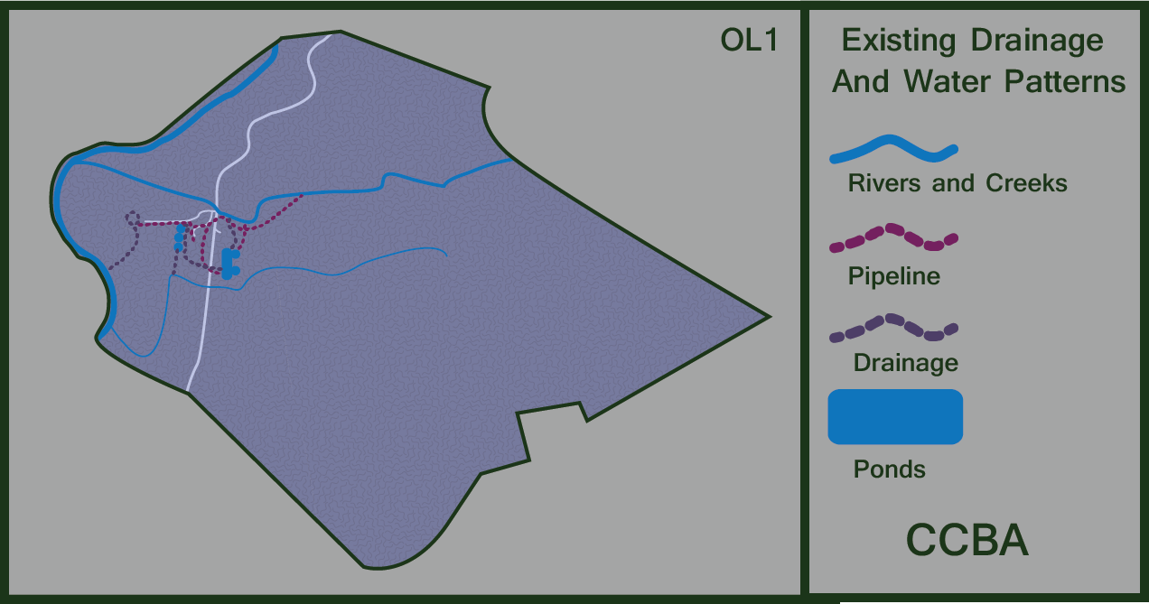

Existing drainage and water quality patterns (OL 1)

In order to maintain high water quality through the production area and flow through the farm it is necessary to maintain the status of primary forest in the upper catchment 45 ha. of the property; as well as 40 ha. of secondary forest of 40 years. This has involved stewardship of the area in and around the farm for health of the forests and equally as important for the downstream watershed of Rio Naranjo Biological Corridor.
The existing drainage pattern demonstrates that Finca Fila Marucha lies within the watershed of Rio Naranjo and three micro tributaries, both of which are named. The streams originate from the primary forest above 450 metres above sea level and pass through the farm and draining into Rio Naranjo. Dominated by broadleaf evergreen primary forests, the upper part of the watershed has perennial springs and has zones of steep drainage and small basins. All of the streamside vegetation is forested with no degraded areas within the immediate creek side vegetation. The riparian edges that had been deforested in the 1970’s have been converted into natural forests with or without anthropogenic influence. The biodiversity representation along the streams is high for the most part, with larger patches of higher biodiversity in the primary undisturbed areas
A total of 3.25 inches of piping brings water to the pond wetlands with a total of 1500 mts. of ponds and small rice paddies. 2 inches reducing to 1.5 inches of continuous piping provides irrigation and infrastructure water needs with water draining off by a series ditches to the ponds below and back into the watershed. Over 25 years two distinct water ecosystems having matured with many amphibian, reptilian species, along with mammals.
A series of piping and ditches surrounds all infrastructure including the lodging, barn/wood storage, compost unit, office/classroom, and la casa principal. The water provides an organic repelling scheme protection from the entomological tide of a rainforest.
With a rainfall of 6,457 mm p/yr erosion control is primordial. Constant ‘upkeep’ of natural drainage patterns into ditches and/or terraces. Vetiveria zinaoides is used as a bio-engineering tool.

The needs of annex VI (4) of the standards must be addressed by managing the flow systems and corridors so that the plantings will connect with other aspects of the landscape.
The primary forested areas in the hills above the farm functions as a water sponge where stable water sources from precipitation can be maintained and released. The vegetation established consists of native species, but the use of exotics to fulfill pioneer functions should not be forgotten. The natural forest in the upper catchments of streams 02 and 03 have a composition floristic with dominant species being Anacardium excelsum, Vochysia ferroginea, Hieronima alchorneoides, Shizolobium parahybum. Given the current high biodiversity state on the streamside vegetation, patch development around any natural regeneration should be the points of application of AF.

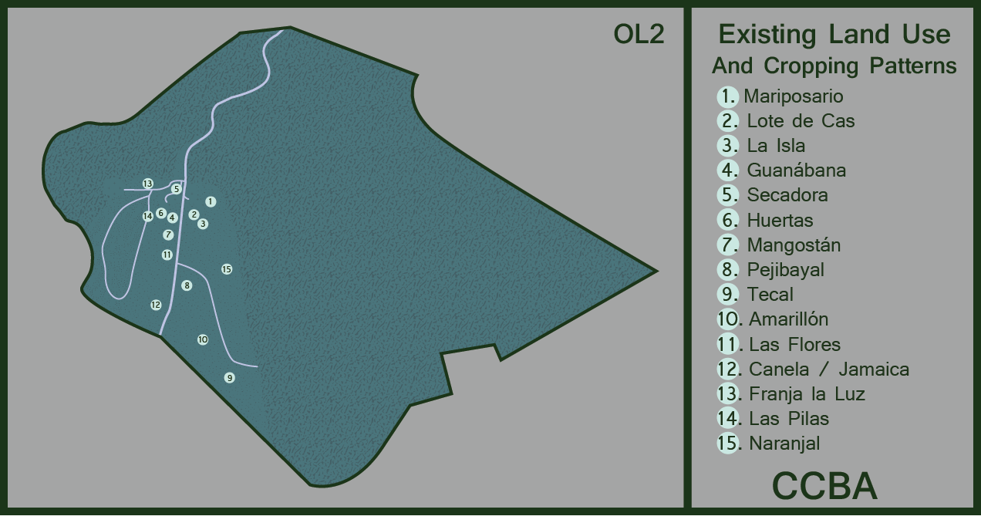

Existing Land use (OL 2)

The production areas of FFM as demarcated in OL 2 are as follows:
Field name Area: 8ha.
- Mariposario
- Lote de Cas
- La Isla
- Guanábana
- Secadora
- Huerta
- Mangostán
- Pejibayal
- Tecal
- Amarillón
- Las Flores
- Canela/Jamaica
- Franja la luz
- Las Pilas
- Naranjal arriba

Some production lots have continued their yields of harvests through regular maintenance, while other fields were left to natural progression processes and yields are minimal with regard to economic crops on a yield per hectare base; nevertheless the long range species within those areas and having been planted have continued their succession. However, in both cases, the ecological seral stages have proceeded in carbon and photosynthetic biomass production (PB).
It is the express objective of Especias Ceilan SA, owner of FFM that analog forests of PB production and conservation be the long-term goal of working the original 12 AF hectares. Thus, economic considerations of each lot, may or not, be the final priority in working the plots. Gap analyses and ecological evaluations will be constantly evolved to be expressed in the yearly nursery.

There are exotic species within the designs of fields that meet the structural and ecological function requirement, such as: Cinnamon, Vanilla, Cardamom, Nutmeg, Annatto, Cacao, Black Pepper, Heliconias, Bactris g., Patchouli, etc.. Other native species of fruits and beverages produce or are coming into small scale production. Due to the nearness of primary forest some of the dominant native species found or may be planted are: Erythrina bertroana, Inga spp., Annacardia excelsum, Schizolobium paranyha, Brosimum spp. Cecopria sp. Cedrela odorata, Cordia alliadora and are found throughout the high intensive AF parcels.

New crops and cropping patterns are in place over the last three years. “Swaths of light” technique developed has been used simulating forest tree falls and planting new crops in the same areas with flowers, medicinal plants, lianas, and palms for new crops. Keystone species are left and/or planted. All of the croplands are surrounded with ample forest buffer zones (500 mts) so that any spray drift of a neighbor is non-existent.

Existing biodiversity patterns fauna

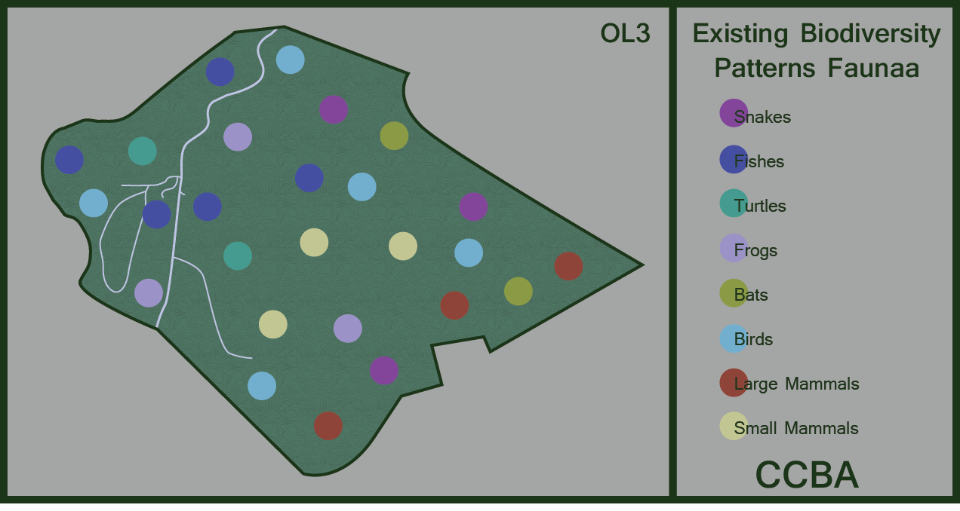
Existing biodiversity patterns fauna (OL 3)

The level of biodiversity is an extremely useful measure of the health of ecosystems. Biodiversity measures have also been correlated with
environmental stability. Similar patterns have been found in studies of the sustainability of agricultural and forestry practice. Thus, the integration of biodiversity needs into natural resource based production systems is essential for management towards a higher degree of stability and sustainability.

The pattern of increasing ecological stability with increasing diversity in land use has been observed in the former degraded areas and their subsequent restoration. High levels of diversity in the agricultural field produce positive effects of biological control; spread the risk in marketing and production. Thus the existing biodiversity pattern has become a critical indicator of management success.

The biodiversity status mapped out for CCBA as OL 3, this map should be used with OL 1 to determine where the biological corridors have been established.

There are six dominant species of fresh water fish: la machaca Brycon behreae, el chupapiedras Sicydium salvini, la olomina Poecilia gillii, la sardina de agua dulce Astyanax aeneus, el tepemechín Agonostomus monticola y la olomina Brachyrhaphis rhabdophora

Aves The watershed is considered a centric region for the distribución de especies such as: el trogón vientribermejo (Trogon bairdii), el tucancillo piquianaranjado (Pteroglossus frantzii), el carpintero nuquidorado (Melanerpes chrysauchen), el saltarín cuellinaranja (Manacus aurantiacus), el batarrá negruzco (Thamnophilus bridgesii), el soterrey pechibarreteado (Thryothorus semibadius), la euphonia vientirrojiza (Euphonia imitans) y la tangara hormiguera cabecinegra (Habia atrimaxillaris).

Fauna

Various groups of mammals are found that include 5 types of feline, coyote, the nutria, mono tití (Saimiri oerstedii), la danta (Tapirus bairdii) y el oso caballo (Mirmecophaga
tridactyla).

Diversidad de especies encontrados en CCBA
_________________________________________________________________
Grupo

Peces
Anfibios
Ranas
Reptiles
Tortugas
Lagartijas
Serpientes
Aves 41 familias
176 species
Mamíferos terrestres 41
Murciélagos
Plantas superiores* 150 familias

The continued protection of the watershed vegetation will contribute positively to increasing indicator species distribution over the management area and beyond. The FFM is located adjacent to Govt. protected lands to the North, and to the East close to 1000 hectares in mature forests are neighboring. With this good amount of forested area and the Rio Naranjo Biological Corridor starting on the farm down to the coast 22 km distance, there is and has been a general restoration of biodiversity due to higher labor costs, land use practices changing, tourism, and appreciation of forest (land) value, along with strict laws prohibiting the felling of one tree without permission from MINAE.

Composting Plan

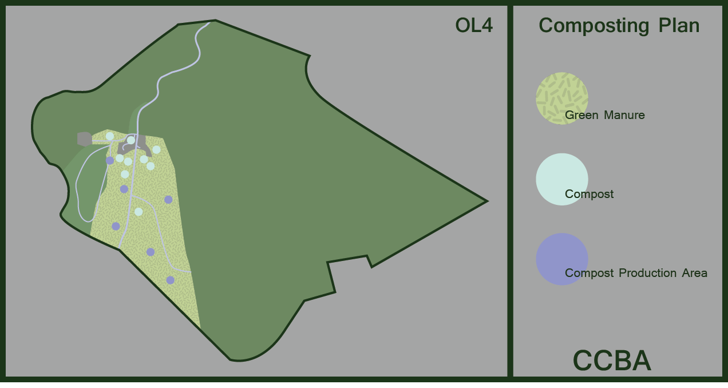
Composting plan (OL4)
A composting and mulching regime is much needed as a parallel operation in the beginning of the (first 10 years of a restoration). After 10 years or so it was found that the need for compost was vastly reduced; if kept up with the mulching regime. A decentralized approach was used to have available one compost pile per 2000 mts2 of terrain p/ six months. This intensive treatment is extremely beneficial to increase drainage as well as improve the microbiology of the soil. The ingredients used are:
- Ash and charcoal
- River sand
- Forest soil starter
- Dried ditch muck
- Animal manure
- Organic material with bio-pesticide qualities

At present, there is a centralized compost production unit under roof that fills the needs of nursery bagging, garden usage, first and second year plantings. A semi-decentralized system may be put into use if planting area increases.
Organic Material
Mulching is done 3 to 4 times per year in situ by machete in the cropping areas and or where there are producing crops. Design of AF can affect positively the access to green manure and native species of the diversified cropping area with legumes and biopesticidal quality, such as: Gliricidia sepium, Poró, Erythrina, Quassia amara, Gavilana, Musaceae, Heliconias. This has been implemented and a permanent decomposed coverage is maintained. A particular emphasis is placed on doubling the amount of OM just prior to the dry season for protection from the loss of soil humidity and protection from insolation.

Defined areas of treatment

In the 8 ha. that have been actively worked through the years, 90% of the parcels have had their ecological succession left unhindered. The 10% is what is being work more intensively. Assisted regeneration can also accelerate the rate of growth by thinning out at 7, 11, 16 years. Eliminating certain pioneer species and strangling vines leaving denser types of forest hardwoods.
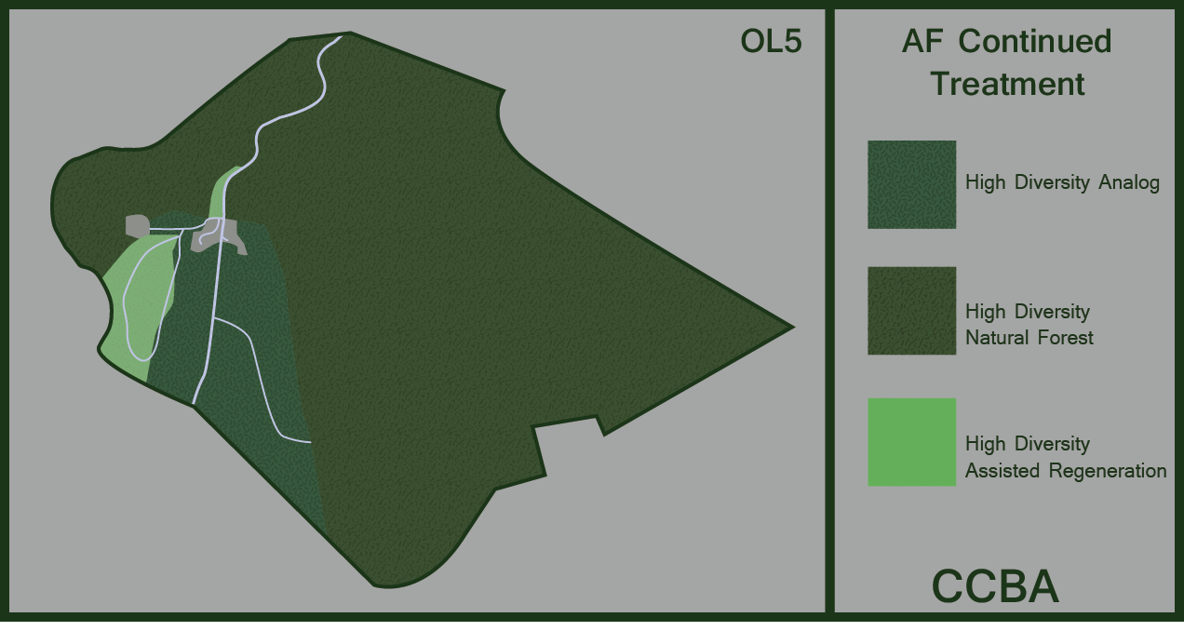AF treatment (OL 5)

One of the objectives of Analog Forestry is to achieve ecosystem
Stability with a more diversified soil rich in organic matter and biologically active. These productive AF ecosystems incorporated into the FFM does, in turn, contribute to biomass accumulation and overall system productivity. This ecosystem is benign to native biodiversity by and demonstrates the elements of structure/function /map as required.

A gap analysis regime has and will be continued to be instituted to maximize the effort to approximate the F1 model used for our design purposes. This will trickle down to the nursery where the list is continuous and seeds planned, sought, and planted.

An analysis of the % of shade is critical for areas determined to be economically viable. Depending on an AF ecological evaluation, the amount of shading and varieties of species, gap analysis, and marketing needs; a determination is made to thin out swaths of light simulating the fall of trees in a forest opening up land for regrowth of commercial species. A short, medium, and long-term approach is taken for the design of the new plantings with regard to species. An ecological evaluation is undertaken to see what lacks as a priority area.

The base map, it’s overlays and the management narrative will explain the guidelines for Analog Forestry design in establishing will allow for the collection of basic information on the characteristics of the surrounding area and the generation of overlay maps of selected crops and indicator species. The AF design follows the physiognomic formula F1 and adjusts to having a percentage of native species and exotics according to the marketing objectives of FFM.

Natural assisted regeneration along the streams banks that border AF cropping areas have become mature; as such care is given to approximate new plantings at a reasonable distance to the denser riparian forest edges. Higher diversity anthropogenic analog production is reserved to a few plots amounting to 2 hectares in total. Native ecosystem restoration of biodiversity, water cleansing function, carbon sequestering is considered also.

Thus the following management processes recommended in the IAFN International Standards FGP are being implemented:

High diversity Analog:
Shade, Water Retention, Wildlife, Fruit, Green Composting material
(GCM):

1) Maintenance of SALT hedgerows and intercrops
2) Maintenance of an active, living soil
3) Effective erosion control
4) Effective weed control
5) Multi storey production, dense planting
7) Closely spaced biodiversity encouraging trees.

Native Ecosystem Restoration:
Native Biodiversity, Water cleansing function, Carbon sequestering

1) Maintenance of high shade cover
2) Maintenance of an active, living soil
3) Effective erosion control
4) Effective weed control
5) Creation of microhabitat for native species
6) Creation of trophic opportunity for native biodiversity.

High diversity Analog:

Native species, spices, medicinal plants, beverages:

The analog sites of high diversity are a mixture of native species planted, naturally sprouted, and exotics. The percentage of native to exotic ranges from 30 % native to 70% native in some parcels. In areas that have been ‘un-worked’ a higher percentage of native species becomes dominant. In some plots, third seral stage is flowing towards maturity given more than 25 years in some plots have been worked. There is a range from 50% canopy coverage to 90% throughout the farm which includes natural assisted regeneration and AF’s. The mature secondary (40+ years) and primary forests are of continuous V8I and V7C

An implementation of a renewal of

- AF mapping of parcels, eco-evaluations
- Gap analyses
- Subsequent nursery listing
- Planting in due time

Ecological Evaluation in natural forest, AF and natural regeneration

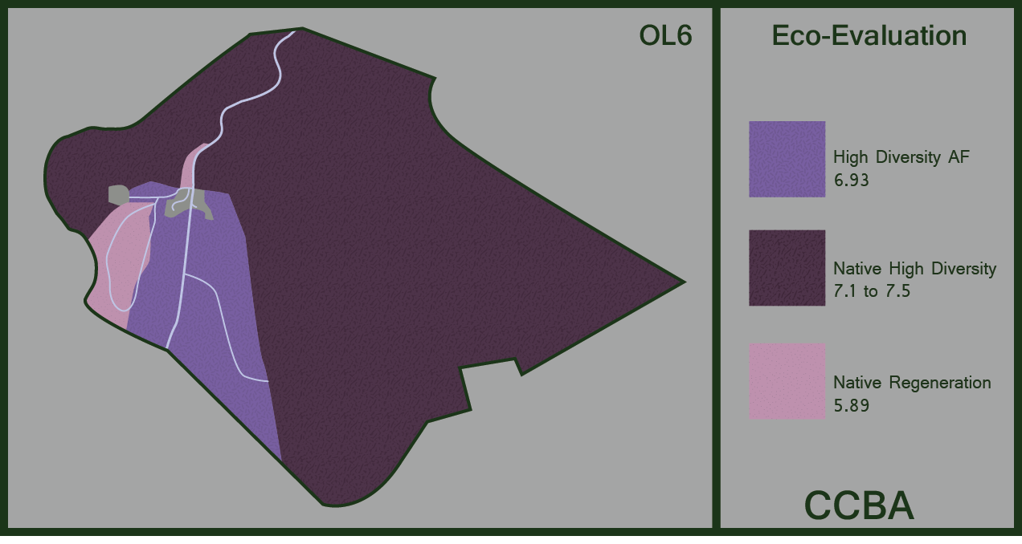

(OL 6)

A study of the different criteria that is a basis for doing and having an evolving Eco-Evaluation of different areas of the farm will give us priority areas to improve. Economic producing parcels, or not, a constant (yearly) analysis of Biodiversity above and below soil, structure, fauna, aves, etc.. is imperative. Production, whether it be crops and biomass should be viewed with the objective of the producer in mind to reach that careful balance between native and exotics that will in the end be more beneficial to nature than man.

As can be seen below in figure 07 the comparison of indicators of the ecological value between natural forest and FA. Production can be seen in the comparison, however in all of the other criteria it is similar with natural forests being in an average higher overall.

Figure 07

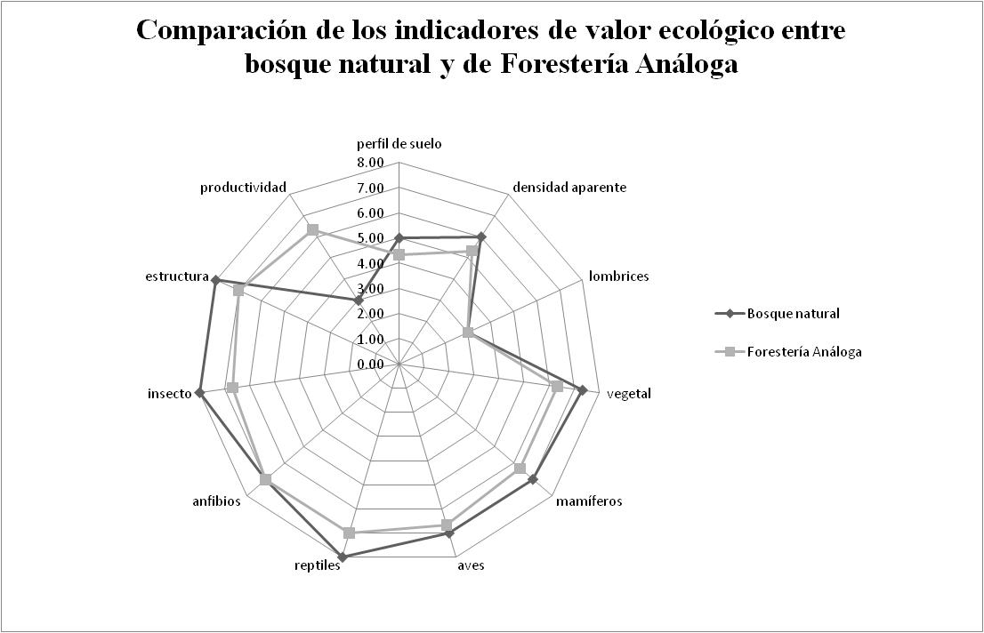

This FGFP has been prepared by CCBA to meet the requirements of the FGP certification scheme of the IAFN.
An effort will also be made to identify documentation for PGS/FGP in Costa Rica.

